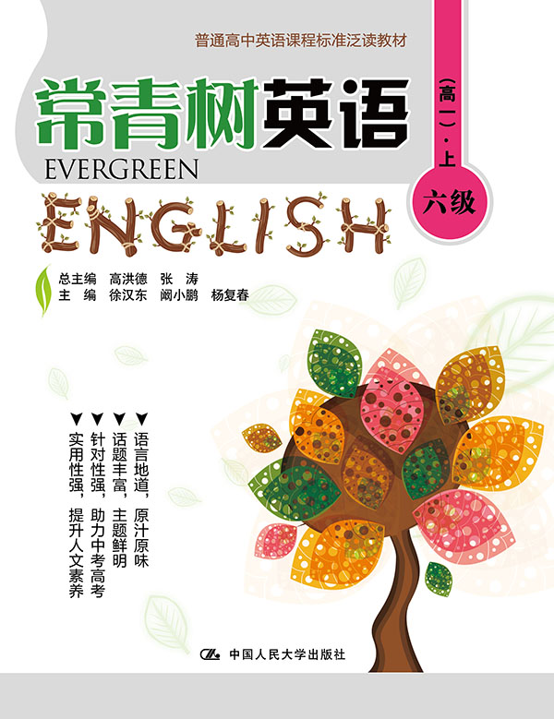
书名：常青树英语 六级（高一）·上
书号：978-7-300-21589-1
作者：高洪德 张涛 徐汉东 阚小鹏 杨复春
责任编辑：程子殊
成品：177*228 页数：243
纸张：70克高白胶
装祯：平装
出版时间：2015年9月
定价：45.00元
出版社：中国人民大学出版社

- 本书卖点
- 语言地道、原汁原味
- 话题丰富、主题鲜明
- 针对性强、助力中考高考
- 实用性强、提升人文素养

◆ 读者定位
高中生

- 作者简介
高洪德，山东省教学研究室英语教研员、特级教师，中国教育学会外语教学专业委员会副理事长、山东省教育学会外语教学研究专业委员会理事长。
张涛，山东省教育学会外语教学研究专业委员会秘书长、山东省教学研究室英语教研员。

- 内容简介
本册是按照《普通高中英语课程标准》六级要求编写的，适合高一年级学生阅读。本书所选文章均来自英美为主的经典语文教材、畅销短篇故事、英美著名报纸、网络刊登的时事新闻、科学发明等。文章话题丰富，或带读者来到缤纷的动物世界，或让读者重温童年的岁月，或教读者勤劳、诚实、真诚等做人的道理。满足学生阅读欲望，充实眼界。

◆ 简要目录
Lesson 1 What Is the Best Day of the Year
Lesson 2 The May Basket
Lesson 3 The Prince and the Judge
Lesson 4 The Gate without a Latch
Lesson 5 True Courage
Lesson 6 To Spank or Not to Spank
Lesson 7 Write or Wrong: the Death of Handwriting
Lesson 8 Gwendolyn Brooks
Lesson 9 The Heroic Daughter
Lesson 10 Cheerfulness
Lesson 11 Stories of the Elephant
Lesson 12 5 Ways to Stop Giving Negative People Too Much Power in Your Life
Lesson 13 The West India Islands
Lesson 14 Why Tablets Are Invading the Classroom
Lesson 15 Take a Moment to Really See
Lesson 16 A Note to Mothers of Only Children—from an Only Child
Lesson 17 Dreams Change the World
Lesson 18 The Best Advice I Ever Had
Lesson 19 We "Discovered" Our Town
Lesson 20 Annie's Dream
Lesson 21 More than One Way to the Square
Lesson 22 Perseverance
Lesson 23 Martial Arts
Lesson 24 The Grimm Brothers
Lesson 25 Harry's Riches
Lesson 26 Susie's Composition
Lesson 27 Who Speaks for the Animals?
Lesson 28 The Ice Cream Girl
Lesson 29 Wish You Weren't Here
Lesson 30 School Colors
Lesson 31 A Dog of Flanders(Ⅰ)
Lesson 32 A Dog of Flanders(Ⅱ)
Lesson 33 The Ugly Duckling
Lesson 34 The Judge and the Beetle
Lesson 35 Thin Ice
Lesson 36 Differences Between British and American Cultures
Lesson 37 The Man with the Cane
Lesson 38 The Gentleman in White
Lesson 39 The Heroic Serf
Lesson 40 Why the Sea Is Salt
Lesson 41 The Beaver
Lesson 42 A Natural Phenomenon—Total Eclipse of the Sun
Lesson 43 The Honest Woodman
Lesson 44 Coffee
Lesson 45 Fidelity
Lesson 46 The Code Talkers
Lesson 47 Try Again
Lesson 48 Columbus
Lesson 49 How the Oak Tree Became King
Lesson 50 The Daisy and the Lark
KEY
◆ 上架建议
中学英语泛读读本

书摘
Lesson 3 The Prince and the Judge
Guidance
To correct mistakes immediately you realize them is the best choice. 知错能改，善莫大焉。

Henry V was as brave a King as ever sat on the English throne, and gained ( 获得) one of the greatest victories ever won by English soldiers.
But when he was Prince of Wales, he was a very wild and riotous ( 放荡的) youth. He mixed with low companions, who led him to do many base ( 不光彩的) and foolish acts, quite unworthy of a Prince.
Once one of his friends was tried for some offense before the Lord Chief Justice. He was found guilty and was ordered to be sent to prison.
When the Prince, who was in the court, heard the sentence, he fell into a great rage. He spoke very rudely to the Judge, and ordered him to let his friend off.
“Prison,” he said, “is no place for a Prince’s friend. I am Prince of Wales, and I forbid you to send this man to prison, like a common thief.”
“Prince or no Prince,” replied the Judge, “you have no right to speak thus to the King’s Judge. I have sworn ( 宣誓) to do justice; and justice I shall do.”
The Prince, getting more angry, then tried to set the prisoner free himself. But the Judge told him it was none of his business, and ordered him to cease from such riot in court.
The calmness with which the Judge spoke made the Prince even more angry; and he rushed up to the bench, and struck the Judge a severe blow on the face!
For this, the Judge ordered the officers of the court to seize the Prince, and take him to prison with his friend. “I do this,” he said, “not because he has done me harm, but because he has insulted ( 损害) the honor of the law.”
Turning again to the Prince, he added, “Young man, you will one day be King. How can you expect your subjects to obey you then, if you yourself thus disobey the King’s laws now?”
On hearing this, the Prince was very much ashamed of himself. He had not a word to say, but, laying down his sword, he bowed to the Judge, and walked quietly off to prison.
When the King (Henry IV) heard of this incident, he said, “Happy is the King that has a Judge who so fearlessly enforces the laws, and a son who knows how to submit to them.”
Shortly after this Prince had been crowned King, many of his people came to pay their respects to him. Some of those who knew how wild he had been as a young man, were anxious to know how he would act as King.
Among the rest came some of his former riotous companions, expecting, no doubt, to be made at once the King’s chief favorite.
But they were mistaken. The King told them that he had given up his foolish ways, and advised them to do the same. Nor would he let them come about his person, until they had shown that they had learned better manners.
The Judge also came, not knowing how he would be received. He feared that he might lose his office; but he did not care, as he had only done his duty.
He was also mistaken. e King received him very kindly and thanked him for the sharp lesson he had given him. He told him still to keep the office which he had so worthily filled.
“If ever,” said the King, “I have a son who shall behave as I did to you, may I have a Judge as bold and faithful as you to correct him!”

